1. **What is our independent variable? What is our dependent variable?**

Independent Variable – Color words congruency condition.

Dependent Variable – Reaction time/Response time to the words

1. **Null and alternative hypotheses are clearly stated in words and mathematically. Symbols in the mathematical statement are defined.**

Ho (Null Hypothesis): This assumes that there is no significant difference between the current population parameters and the new population parameters after the intervention/interference.

Ho: μ = μI (This does not mean that they are exactly similar)

μ - Current population mean

μI – Population mean after intervention/interference

**Ho: In the Stroop effect experiment the null hypothesis is there will be no significant difference in the reaction time of the participant when the ink color matches the name and when the ink color is different from the name.**

Ha (Alternative Hypothesis): This assumes that there will be significant difference between the current population parameters and the new population parameters after the intervention/interference.

Ha : μ < μI (Current population mean is less than the Population mean after intervention/interference)

Ha : μ > μI (Current population mean is greater than the Population mean after intervention/interference)

Ha: μ ≠ μI (Current population mean is not same as the Population mean after intervention/interference but we don’t know which direction it is in.)

**Ha: In the Stroop effect experiment the alternative hypothesis is the reaction time of the participant would be significantly larger when the ink color matches the name and when the ink color is different from the name.**

1. **A statistical test is proposed which will distinguish the proposed hypotheses. Any assumptions made by the statistical test are addressed.**

The statistical test appropriate for this experiment is a paired t-test as:-

* We have less than 30 samples
* We don’t know the population’s standard deviation

The experiment we are conducting is dependent because we are using the same sample of people for the congruent and incongruent conditions.

The assumptions for the test are:-

* Your dependent variable should be measured at the interval or ratio level (i.e., they are continuous)
* The independent variable should consist of two categorical, "related groups" or "matched pairs".
* There should be no significant outliers in the differences between the two related groups.
* The distribution of the differences in the dependent variable between the two related groups should be approximately normally distributed.

1. **Report some descriptive statistics regarding this dataset. Include at least one measure of central tendency and at least one measure of variability.**

There are 24 observations in the dataset each having a value for congruent and incongruent task which show how each participant performed on the Stroop task.

Measure of centrality:

1. Mean for congruent data:

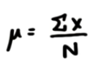

= Sum of all congruent values

N

= 337.227

24

μ = 14.05

Mean for incongruent data:

μ = 22

Measure of Variability:

Sample standard Deviation for Congruent Data:

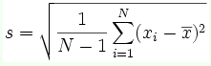

σ = 3.56

Sample standard Deviation for Incongruent Data:

σ = 4.8

1. **Provide one or two visualizations that show the distribution of the sample data. Write one or two sentences noting what you observe about the plot or plots.**

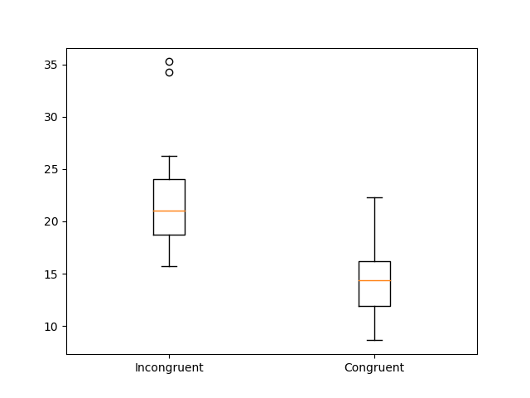

From the above box plots we can clearly see that the incongruent times are more than the congruent times. The range of values for incongruent readings is more than the congruent readings which clearly shows us that the interference does indeed increase the reaction time.

1. **A statistical test has been correctly performed and reported, including test statistic, p-value, and test result. The test results are interpreted in terms of the experimental task performed.**

There are 24 observations i.e. n = 24

First we calculate the difference between the two sets of data in the following table:-

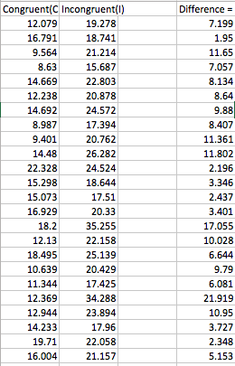

Mean of the difference (d) = 7.965

Sample Standard Deviation (Sd) = 4.86

t = d/ (Sd/sqrt(n))

= 7.965/(4.86/sqrt(24))

= 8.02

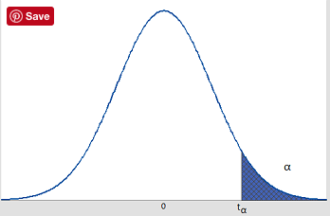

In the above figure α = 0.05 and tα = 1.714 for 23 degrees of freedom. Since our t-statistic is 8.02 it is well above 1.714 and is in the critical region, so we reject the null hypothesis which brings us to the conclusion that the incongruent condition has a significant effect on the reaction time of the participant as the reaction time is significantly larger.

p-value < 0.00001

Bibliography:-

1. http://www.statisticshowto.com/probability-and-statistics/z-score/